Samuel Bismuth 342533064
Johann Thuillier 336104120

Assignment 1 – Databases.

Question 1 -

SELECT CompanyName, City
FROM Suppliers
WHERE SupplierID IN (SELECT SupplierID
FROM Products
WHERE CategoryID = (SELECT CategoryID
FROM Categories
WHERE CategoryName = 'Confections'
))

The meaning of this query :

SELECT CompanyName, City
FROM Suppliers

- We’re asking for two columns “CompanyName” and “City” which are found in the “Suppliers” table. From this two columns, we want to do a selection of lines (i.e : we only want some lines between all the lines that the raws contain), such that :

WHERE SupplierID IN (

- We are looking the row “SupplierID” (which is in the “Suppliers” table), and by the IN operator, we mean that we only want all the lines where the “SupplierID” case corresponds to the following :

SELECT SupplierID
FROM Products

- In the table “Products” we’re looking to the column “SupplierID” (Attention, this column “SupplierID” is not the same that the column “SupplierID” we saw above because both do not belong to the same table). From this column, we’re doing a new selection which is to only worried about the following lines :

WHERE CategoryID = (

- In the same table as above (Products) we’re looking about the column “CategoryID”. From that column, we want the union with the following lines :

SELECT CategoryID
FROM Categories
WHERE CategoryName = 'Confections'
))

- In the table “Categories” and in the column “CategoryID” we want the lines where the column “CategoryName” (which is in the same table (“Category”)) is equal to ‘Confections’.

- If any line is matching with all the condition of the query, this line will be return.
Here are screen-shot of the result of the query in mySql :

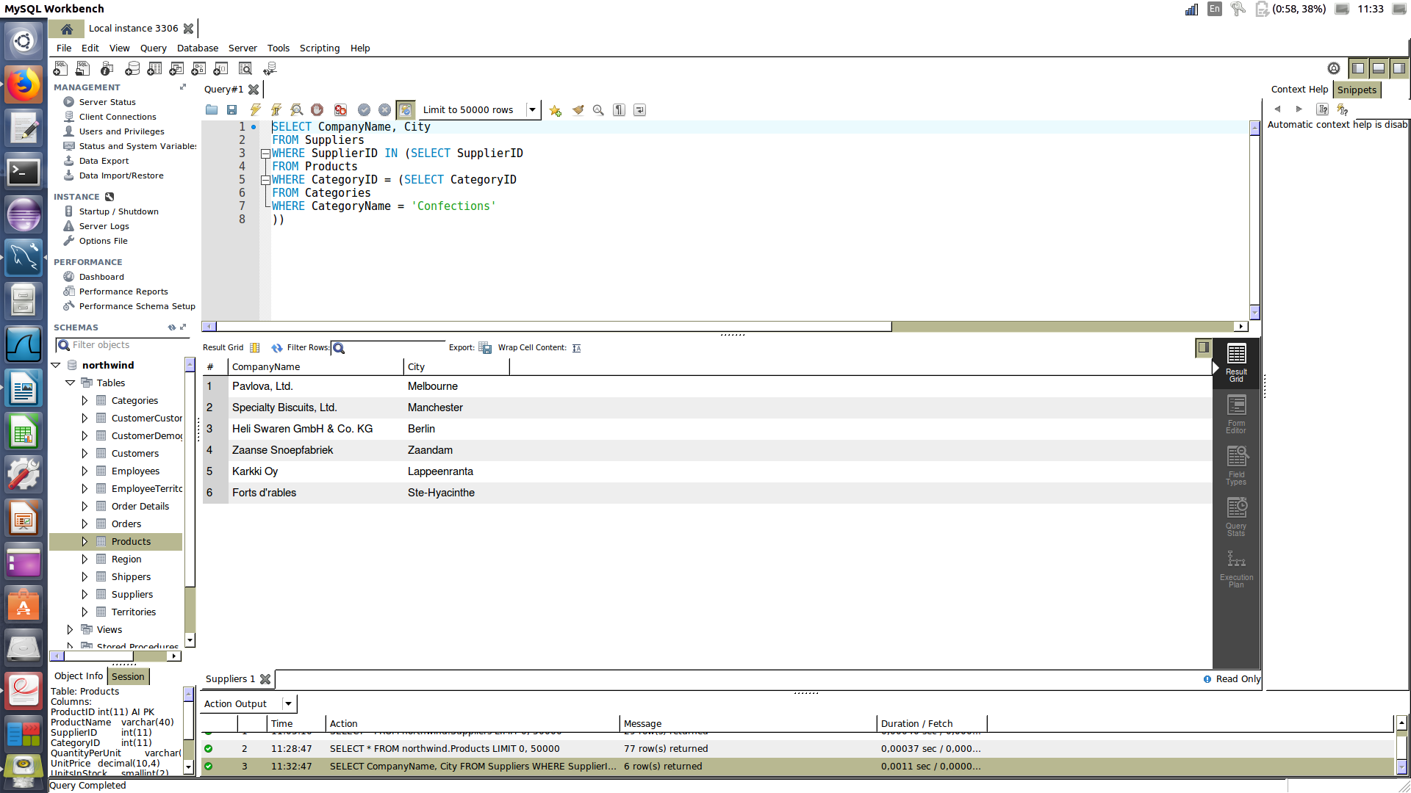

Question 2 -

SELECT productName, SupplierID
FROM Products
WHERE SupplierID IN (SELECT SupplierID
FROM Suppliers
WHERE CompanyName IN ('Exotic Liquids', 'Grandma Kelly''s Homestead')
)

Here are screen-shot of the result of the query in mySql :

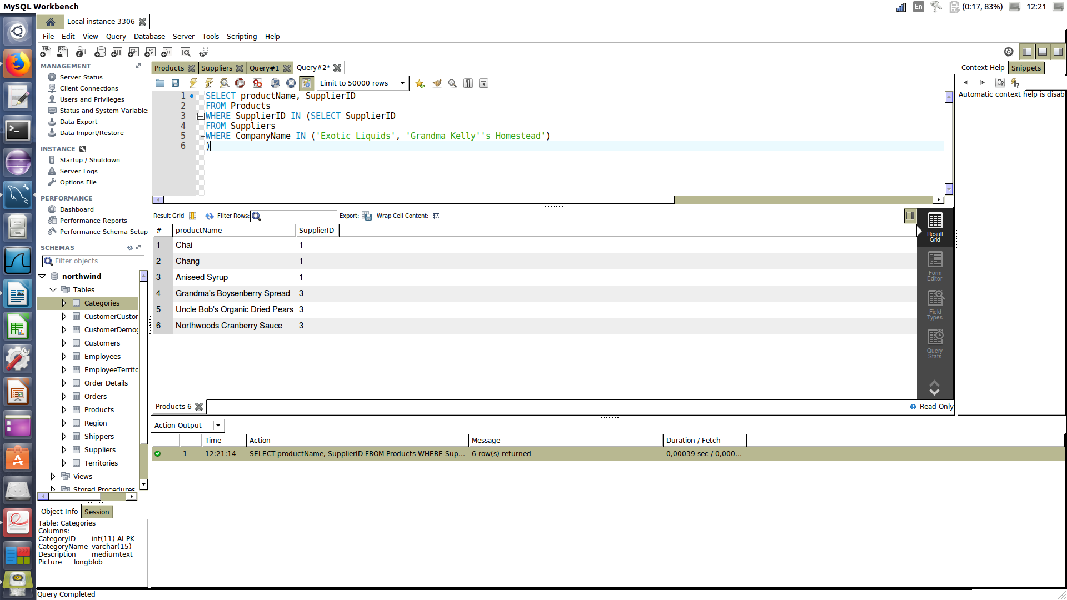

Question 3 -

We’re giving two answers since there numerous ways to get the data of the picture.

The first answer is to create a new column and to select it. Attention, here the column is really created, not only shown.

The query we should ask to get this result is :

ALTER TABLE Products ADD COLUMN shortPrice CHAR(6) AS (CONCAT('$', UnitPrice));
SELECT ProductID, ProductName, UnitPrice, shortPrice
FROM Products;

Here are screen-shot of the result of the query in mySql :

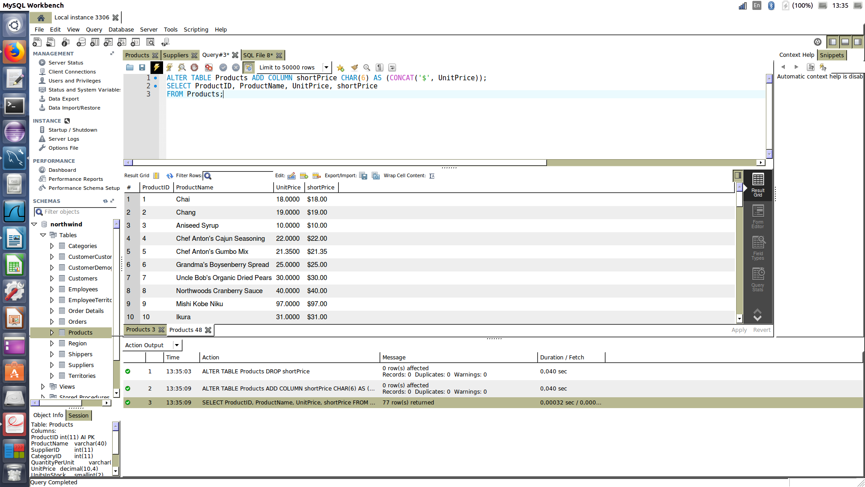

The second answer shall only shown the column without create it for real.

The query we should ask to get this result is :

SELECT ProductID, ProductName, UnitPrice, CAST((CONCAT('$', UnitPrice)) AS CHAR(6)) AS 'shortPrice'
FROM Products;

Here are screen-shot of the result of the query in mySql :

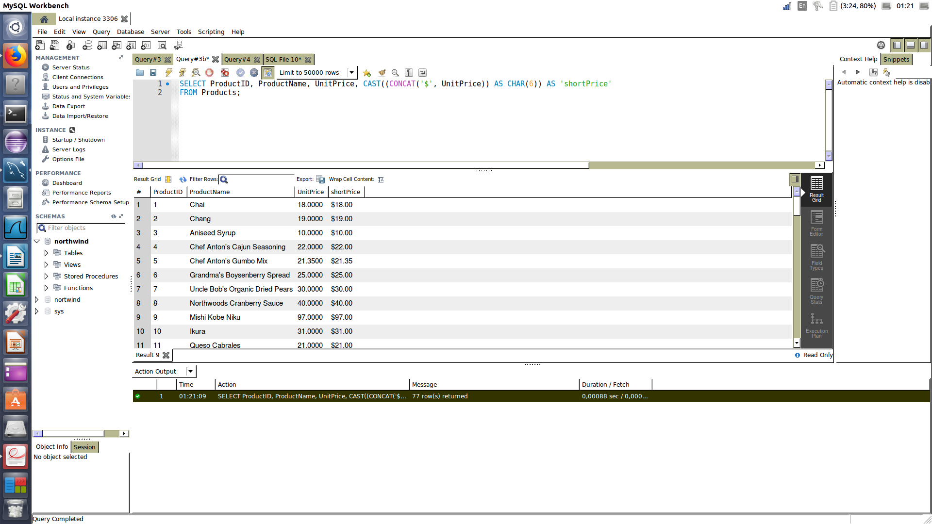

Question 4 -

# The return must be the name of the client.
# For each of them, employee (which handle the command) and the shipper have 's' as first leter of their name.
# We also need to add the sum of the command.

SELECT Cust.ContactName, SUM(OrdDet.Quantity * OrdDet.UnitPrice - OrdDet.Discount * (OrdDet.UnitPrice * OrdDet.Quantity)) AS total
FROM Orders Ord

INNER JOIN `Order Details` OrdDet
ON Ord.OrderID = OrdDet.OrderId

INNER JOIN Customers Cust
ON Ord.CustomerID = Cust.CustomerID

LEFT OUTER JOIN Shippers Ship
ON Ord.ShipVia = Ship.ShipperID

WHERE

Ord.EmployeeID IN (
SELECT EmployeeID
FROM Employees
WHERE FirstName
LIKE 's%')

AND

Ord.ShipVia IN (
SELECT ShipperID
FROM Shippers
WHERE CompanyName
LIKE 's%')
group by ContactName;

Here are screen-shot of the result of the query in mySql :

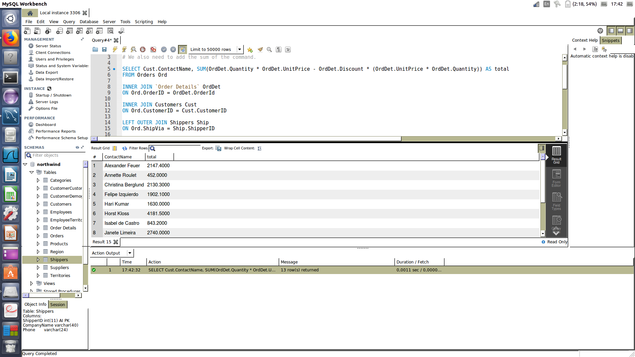

Question 5 -

# This query subscribe for all suppliers the product which have been buy the most number of time by the client in the month ‫‪07.1996‬‬
# And who much money client buy it.

SELECT

ContactName,
ProductName,
MAX(orderedCount) as `Ordered count`,
SUM(UnitPrice * Quantity) as `Total price`

FROM (

SELECT

sup.ContactName,
pro.ProductName,
COUNT(ord.CustomerID) as orderedCount,
ordDet.Quantity,
ordDet.UnitPrice

FROM

Products AS pro
INNER JOIN `Order Details` AS ordDet ON pro.ProductID = ordDet.ProductID
INNER JOIN Orders AS ord ON ordDet.OrderID = ord.OrderID
INNER JOIN Suppliers AS sup ON sup.SupplierID = pro.SupplierID

WHERE

ord.OrderDate BETWEEN '1996-07-00' AND '1996-07-31'

GROUP BY ordDet.ProductID

) AS subQuery

GROUP BY ContactName

Here are screen-shot of the result of the query in mySql :

